**Day 3: Links and Images 🔗🖼️**

Welcome to Day 3! Today, we're going to bring our pages to life by connecting them to the rest of the internet and adding visual content. We'll learn how to create hyperlinks and display images, two of the most essential features of the web.

**Connecting the Web: The Anchor Tag <a>**

The "HyperText" in HTML is all about links. Links, or hyperlinks, are what allow us to navigate from one page to another. The tag used for this is the <a> tag, which stands for **anchor**.

An <a> tag on its own does nothing. It needs an **attribute** to tell it where to link to.

* The href Attribute: This stands for **h**ypertext **ref**erence, and it's the most important attribute for the <a> tag. Its value is the destination URL or file path you want to link to.

**Example 1: Linking to an External Website**

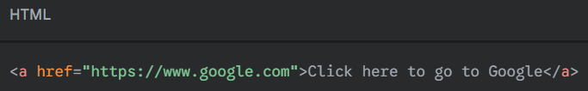To link to a site like Google, you use its full URL.

The text between the opening <a> and closing </a> tags becomes the clickable link on the page.

**Opening Links in a New Tab**

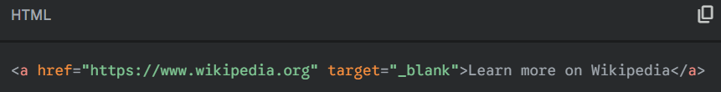Often, when you link to an external site, you don't want the user to leave your page. You can make the link open in a new browser tab by adding the target="_blank" attribute.

**Example 2: Linking to Another Page on Your Site**

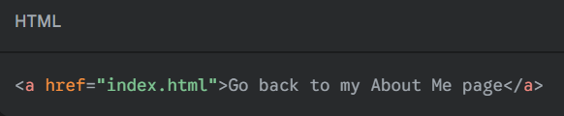You can also link to other HTML files within your own project folder. If you want to link from your recipe.html page back to your index.html page, you just use the file name in the href attribute. This is called a **relative link**.

**Displaying Visuals: The Image Tag <img>**

Images make webpages more engaging. To add an image, we use the **<img>** tag.

The **<img>** tag is a special kind of tag called a **void** or **self-closing** tag. It doesn't have a closing tag because it doesn't wrap around any content.

The **<img>** tag requires two essential attributes:

1. **src (Source):** This attribute works just like the href in an anchor tag. It's the path or URL to the image file you want to display.
2. 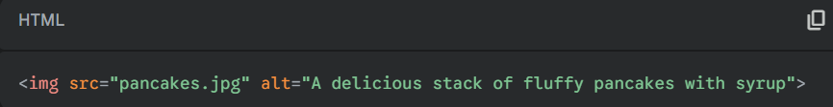**alt (Alternative Text**): This text is incredibly important for **accessibility**. If a user is visually impaired and using a screen reader, the alt text will be read aloud to describe the image. It's also displayed if the image fails to load for any reason. **Always include descriptive alt text!**

**A Quick Note on File Paths**

Where you save your files matters! It's a best practice to keep your project organized.

1. Inside your my-first-website folder, create a **new folder** and name it images.
2. Save all your image files inside this new images folder.

Now, to access an image from your HTML file, you need to tell the browser to look inside that folder. You do this by including the folder name in the src path:

<img src="images/pancakes.jpg" alt="A delicious stack of fluffy pancakes with syrup">